706.030 - Computational Modelling of Social Systems - SS2024

Project Report

Agent-based Modelling (ABM)

–

Simulating Societal Collapse in   
Multi-Generational Space Travel



Group 17

Tanja Boric

Niklas David Schramm

Paul Jakob Sedlmayr

Verena Grall

**Table of Contents**

Introduction and Motivation 3

Base Model 4

Objectives and Scope 4

Agents 5

Environment 5

Parameters 5

Assumptions 6

Mechanics 6

Goal 6

Research Question 6

Extending the Base Model 7

Attractiveness 7

Attractiveness Match 7

Acceptance Probability 7

Acceptance Decision 7

Conditions for Acceptance 8

Polarizing View 8

Agent-specific Additions 9

Check Difference in *PolarizingView* Values 9

Kill Agent 10

Analysis 10

Alternative model with our own parameters 11

Conclusion 13

Limitations and Future Research 14

Literature 15

# **Introduction and Motivation**

Interstellar travel and surviving in space settlements have become increasingly relevant topics in the past years [1,2,3,4]. Environmental hazards as well as scientific developments in the past years present the necessity but also the unique challenge for humanity to consider a millennia lasting space journey.

Long distance space missions are characterized by long durations and limited resources. With current technology, it would take approximately 6,300 years to travel to the nearest solar system, Alpha Centaury [2]. In science fiction, this problem is often addressed with cryonics, a procedure of “freezing” the crew. As there was no breakthrough in cryonics, it stays within the realm of science fiction. Given that space travel exceeds human lifetime, long distance space travel requires multiple generations to achieve this goal. This raises the question what requirements a population would need to meet to sustain themselves over time periods as long as the proposed 6,300 years.

In 2018, Marin & Beluffi estimated that 98 individuals are the minimal number for a genetically healthy population size necessary for surviving such extended periods of time [2]. Similarly, Salotti calculated a minimum of 110 settlers necessary to populate another planet [3]. These estimates are based on a best-case scenario where settlers set individual goals and differences aside to achieve a common goal.   
Historically, periods of societal stability lasting as long as 6,300 years have been rare. While discussions on social factors in this context have received some attention (see [3,4]), the topic remains underexplored. In 2019, Haqq-Misra argued that selfless, deep, altruism would be necessary to achieve this goal [1]. However, humans often pursue selfish objectives, such as maximizing the potential for spreading their genes through selective mating processes based on attractiveness. Additionally, humans are prone to selfish and irrational behavior, exemplified by conflicts and, in extreme cases, murder within the same society. History is characterized by instances of irrational mass-behavior such as civil wars, where (usually genetically similar) individuals turn on each other due to different beliefs. When analyzing the relevant factors for survival on a multi-generational space travel, it is essential to consider selfish or irrational social behavior. In 2019, Szocik concluded that “*ethical and social virtues, not current technological and medical threats, are the biggest risk for success of the mission*” [4].

This paper aims to incorporate attractiveness-based mating into the complex task of sustaining a society with limited resources over multiple generations Additionally, we intend to explore the impact of civil war-like homicides stemming from radical differences in viewpoints. By examining these forms of counterproductive social behavior, we seek to understand their effects on survival. An agent-based model (ABM) about surviving a 6,300-year-long space flight to Proxima Centauri b is the basis for this project [2,5].

# **Base Model**

The foundational model created by Sommer simulates life on a space shuttle during a 6,300-years long flight to Proxima Centauri b [5]. It is based on an astrophysics paper by Marin & Beluffi [2]. An overview of the main components of the model is given in this section.

## **Objectives and Scope**

The agent-based modelling (ABM) approach is based on a NetLogo model and simulates a multi-generational space flight. The focus lies on sustaining the survival of humankind as well as the dynamics of a human crew, and if or how it is possible to maintain a stable population throughout the travel. It contains realistic data - these parameters are based on further research. Key components of the model are agents, different parameters, the environment, and some assumptions.

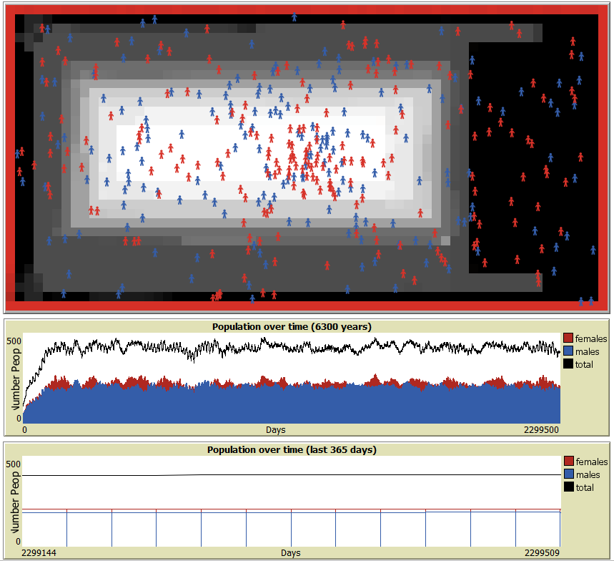  
Figure 1: The world view in Netlogo and monitors that track the population growth.

### **Agents**

The agents represent humans on the space shuttle. There are females (red) as well as males (blue) with characteristics like age, movement, mating behaviour, fertility, pregnancy status and number of children. Their movement can be tracked in Netlogo’s world view window (see Figure 1).

### **Environment**

The spaceship is divided into different zones where agents can move in-between, and every zone has an individual accident probability. E.g., the white zone (see Figure 1) in the middle of the spaceship has the smallest probability of accidents to occur. Pregnant female agents and children stay in this area for safety purposes.

### **Parameters**

The crew size is the initial number of crew members. The male-female ratio is set to 50:50. Based on real life data, a realistic fertility rate was also implemented in this model. Agents have age-related fertility and mortality rates. Therefore, aspects such as menopause are considered.

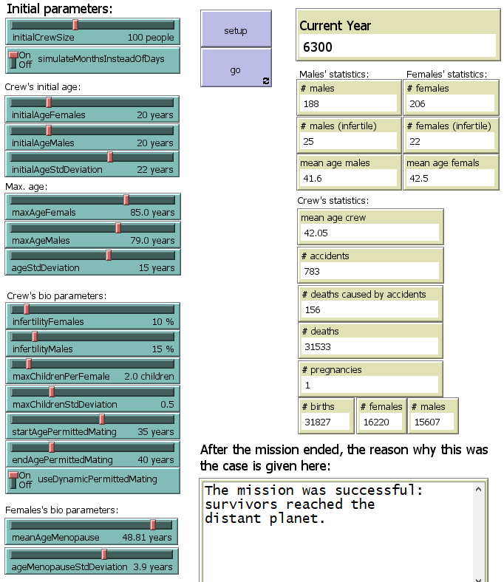  
Figure 2: Parameters and monitors in the Netlogo model.

### **Assumptions**

The base model assumes that the resources for the crew are unlimited, and maintenance is not needed. Social dynamics are simplified in this model, with basic interaction rules and no complex social or psychological behaviour. For example, if a male and a female agent meet and a pregnancy is possible, they will mate and produce a child with a specified probability in regard to their fertility rate.

### **Mechanics**

Changes over time that can be observed in the base model are the population, including the number of births, deaths and aging. Crew demographics, such as age distribution, gender ratios and fertility, are set as parameters. Due to the possibility of random accidents occurring on the spaceship that can cause death, a specific monitor displays the death counter for keeping track of the number.

### **Goal**

The main criteriafor the mission’s success is reaching the end of the simulation with a living crew, which would imply that the space shuttle’s crew has indeed arrived on Proxima Centauri b after the timespan of 6,300 years. The mission fails if the crew goes extinct or overpopulation is reached.

# **Research Question**

Based on the extension of the base model in this research, the following **research question** will be the focus of the latter half of this paper:

*After the introduction of selective dating preferences,*   
*at what difference threshold in polarizing view values does the society go extinct because it cannot sustain itself any longer*?

Attractiveness-based selective mating was selected to emulate more complex mating behaviour beyond simple instinctual reflexes. The idea is to give the agents a choice based on their own preferences according to their own attractiveness derived from a date choice model [6], ideally selecting someone who is in their “league”, which comes close to in-real-life behaviour in dating apps and the tendency of selecting attractive mates.  
  
A homicide mechanic was introduced based on research about simulating irrational human behaviour [8]. The goal was to prevent resource depletion. Since in this model, unlimited resources are assumed, we only want to observe the impact on the population growth and at what point the differences pose a significant danger.

# **Extending the Base Model**

Based on the initial model, further elements were added for this research, namely a more complex mate selection based on attractiveness [6,7], as well as social conflicts caused by polarizing views, including the possibility of getting killed by murder [8].

## **Attractiveness**

This research extends the base model by adding a more complex mate selection process based on the date choice model by Kalick and Hamilton from 1986 [7]. The initial mating process was very simple. When a male and female agent met, it only checked if pregnancy is possible. The extended model includes a probability-based declination possibility to simulate selectiveness. With this implemented, there is a newly added probability variable that influences the success of the mating process. The purpose is to simulate mutual consent in a more realistic social interaction. The mate selection is based on attractiveness values (range 1-10) that were assigned to each agent randomly at their time of birth. When two agents meet, the individual differences in values are calculated. The smaller the difference, the higher the acceptance probability (in percent) for mating. If the attractiveness difference is large, the probability of mating decreases, and a rejection may occur.

### **Attractiveness Match**

When a potential partner is found, the attractiveness difference (*attractivenessMatch*) between the male and female is calculated. This difference can be positive or negative, indicating how much more or less attractive the partner is compared to the agent.

let attractivenessMatch (attractiveness - [attractiveness] of partner)

### **Acceptance Probability**

The probability percentage rate (ranged between 0 and 1) is calculated using the absolute value of the attractiveness difference. We use *abs* to ensure that the difference is always non-negative. By subtracting from 1, we invert the probability, meaning that a smaller attractiveness difference results in a higher acceptance probability, while a larger difference results in a lower acceptance probability.

let acceptProbability (1 - abs(attractivenessMatch) / 10)

### **Acceptance Decision**

Agents (both male and female) decide whether to accept the partner based on this calculated probability. Both agents must independently agree (based on their own acceptance probability) for mating to occur.

if random-float 1 <= acceptProbability and random-float 1 <= acceptProbability

### **Conditions for Acceptance**

The probability of acceptance depends on how close the agents' attractiveness levels are to each other. Agents are more likely to accept partners whose attractiveness is similar to their own.

For example: If the attractiveness difference is...

* 0, the acceptance probability is 1.0 (100% chance of acceptance).
* 5, the acceptance probability is 0.5 (50% chance of acceptance).
* 9, the acceptance probability is 0.1 (10% chance of acceptance).

*Example Scenario*:   
We have a male agent with attractiveness = 7 and a female agent with   
attractiveness = 5.   
*Calculate Attractiveness Match*: let attractivenessMatch(7-5), which is 2.  
*Determine Acceptance Probability*: let acceptProbability(1-abs(2)/10), which is 0.8  
*Acceptance Decision*: Both agents will generate a random number between 0 and 1.  
If both random numbers are ≤ 0.8, the agents accept each other, and mating occurs.  
If either agent's random number is > 0.8, the mating attempt fails.

## **Polarizing View**

This research extends the base model by adding a possibility of agents getting killed by other agents, on top of mating selectiveness. The homicide rate is based on the differences in each agent’s polarizing view value, which is assigned randomly at their time of birth (range 1-10). The “polarizing view” aspect is a placeholder and stands representatively for any kind of possible opposing views, such as religious, political, ethical, national, moral, etc. The reasoning behind this is that in basic societies, each human’s approval of another human is influenced by their personal point of view, and if their differences are too vast, it can often be interpreted as a threat. In this simulation, the differences in the polarizing view values are calculated each time when two agents meet outside of the white safety zone on the ship. If the values of two agents are too far from each other, which would imply a big difference in their views, one of the two agents gets killed (randomly decided).

*Example Scenario*:   
Depending on the threshold that is set in the model, if two agents named A and B meet outside of the white zone, they will try to kill each other if it exceeds the threshold limit. If agent A has a pv-value of 2, they will try to kill each other if...  
 - ... the threshold is set at 5 and B has a pv-value of 7.   
 - ... the threshold is set at 6 and B has a pv-value of 8.   
 - ... the threshold is set at 7 and B has a pv-value of 9.

Ein Bild, das Text, Screenshot, Diagramm, Design enthält.

Beschreibung automatisch generiert.Ein Bild, das Text, Screenshot, Diagramm, Design enthält.

Beschreibung automatisch generiert.Ein Bild, das Text, Screenshot, Diagramm, Design enthält.

Beschreibung automatisch generiert.  
Figure 3: With different thresholds, at which value of B would A and B kill each if A is at 2?

The goal of the RQ is to test these different values to find the exact thresholds. In detail, a result showcasing an extinction scenario would imply that the agents keep killing each other at a higher rate than they are able to reproduce, because the difference values in polarizing views are too narrow, suggesting that the number of agents that have outer values is too numerous.

For example, in Figure 4, we can see that the killing rate at every encounter of agent A and B would probably be around 50% because the green bar (allowed difference in polarizing view values where they would not try to kill each other) is only 5, therefore if A is at a lower spectrum and B at a higher spectrum (two opposing, extreme values), they become hostile and the homicide logic would apply if the threshold for killing was then set at 5 or higher (in code, it would translate to “*I can kill the other agent if our difference is 5 or higher*”).

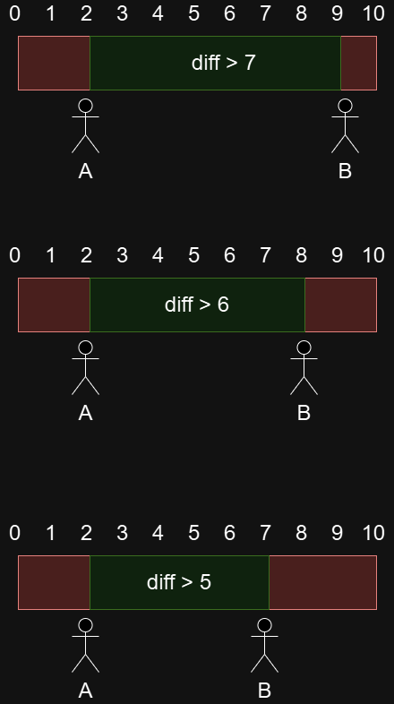  
Figure 4: Agent A with a pv_value of 2 and agent B with a pv_value of 7.

### **Agent-specific Additions**

A new *polarizing_view* parameter was added to each object struct (male & female agents) and is set randomly between 1-10 at time of birth (in *actFemales* function).

set *polarizing_view* random-float 10

### **Check Difference in *PolarizingView* Values**

A new function *checkPolarizingView* was added in the *setup* function. This function only concerns agents outside of the safety-zone to avoid checking each agent’s age, gender and pregnancy status. Therefore, agents won't kill pregnant females or children by default since they only stay in the white (safe) zone. When two agents meet outside of the safety zone, the difference is checked:

let view-difference abs (polarizing_view - [polarizing_view] of other-turtle)

### **Kill Agent**

If *view_difference* surpasses a certain threshold, one of the two agents dies (randomly chosen) and the other one survives the encounter.

let to-die one-of (list self other-turtle)

ask to-die [ die ]

+1 is added to the *polarizing_view* kill counter (only for statistical purposes).

set numberKillsByViewDifference numberKillsByViewDifference + 1

# **Analysis**

To measure the population's size over the years based on the polarizing view thresholds that were set in the code, we could observe different outcomes in the overall survival rate of the society (see Figure 5).

To observe the survival rate of the crew depending on all the threshold differences, we run a calculation over all the thresholds and put them side by side for comparison. In the final simulation, all societies went extinct at threshold 6 because the differences tolerance in opposing values was to narrow, therefore too many agents ended up killing each other. At threshold 7 onwards, the societies tended to survive the included homicide rates, albeit we could see their growth being impacted (like in Figure 7).

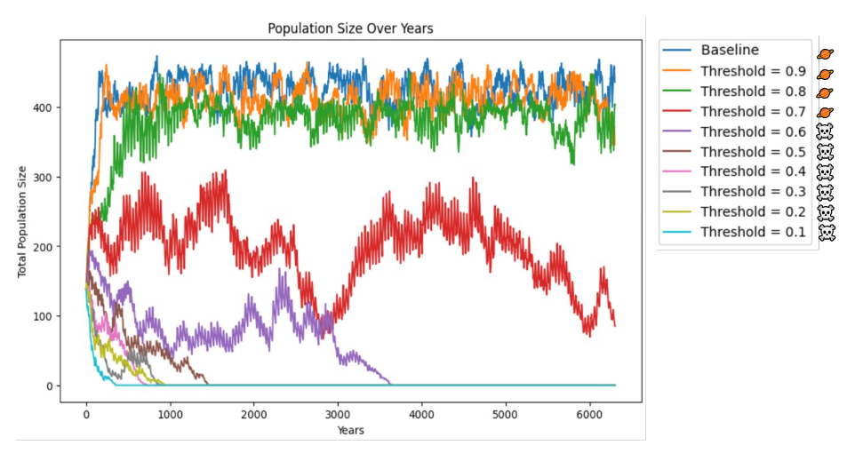Figure 5: Simulating populations with different thresholds.

After adding only attractiveness-based selectiveness to the base model, we could observe that the society fluctuates for the first few centuries but stabilizes over time:

Ein Bild, das Text, Screenshot, Display, Software enthält.

Beschreibung automatisch generiert.  
Figure 6: Base model with only attractiveness-based selectiveness added.

After adding attractiveness-based selectiveness and a homicide possibility caused by differences in polarizing views, we could observe that the society survives at a polarizing view difference threshold of 7, but there is a visibly lower population growth that impacts the probability of certain survival:

Ein Bild, das Text, Elektronik, Display, Screenshot enthält.

Beschreibung automatisch generiert.  
Figure 7: Base model with selectiveness & polarizing view at threshold 7.

The society goes extinct at a polarizing view difference threshold of 6:

Ein Bild, das Text, Screenshot, Display, Software enthält.

Beschreibung automatisch generiert.  
Figure 8: Base model with selectiveness & polarizing view at threshold 7.

## **Alternative model with our own parameters**

Additionally, we have conducted our own research and further modified the extended model with our own parameters to see if there is a different outcome with new data.

The original authors used values for parameters such as the fertility rate that they have chosen based on other sources. After taking a closer look at these, it could be observed that many of those values are not up to date and may not be representative for current data and conditions. For some values, no source or reasoning was given at all. For example, regarding the onset of the menopause, the authors referred to a study from 1975, but no source for the life expectancy was provided. For this reason, we chose our own scientific research data for adapting the model with newer values.

Ein Bild, das Text, Display, Screenshot, Software enthält.

Beschreibung automatisch generiert.Figure 9: Alternative model with our own parameters (based on background research).

The following parameters from the base model were adjusted to new values:

|  |  |  |  |  |
| --- | --- | --- | --- | --- |
|  | | | | |
| Parameter | Old value | Old reference year | New value | New reference year |
| MaxAgeFemales | 85.0 | NA | 73.8 | 2021 |
| MaxAgeMales | 79.0 | NA | 68.4 | 2021 |
| InfertilityFemales | 10% | NA | 17.5% | 2023 |
| InfertilityMales | 15% | NA | 17.5% | 2023 |
| MeanAgeMeno-pause | 48.81 | 1975 | 50 | 2021 |
| AgeMenopause-StdDevitation | 3.9 | NA | 5.0 | 2021 |
| getsPregnant | 75% | NA | 20 – 70% | 2022-2024 |
| isTwin | 2% | NA | 3% | 2021 |

Table 1: Overview of changed parameters

The new data is based on different sources based on current research ranging from 2021 to 2024. This updated data helps us with showing how the space voyage would fare if we assume current conditions and data, and if it would impact the survival of the spaceship’s society.

**Age**: For adjusting the parameters of the life expectancy of the passengers, the work from Roser et al was consulted [9]. On their website, they keep an updated oversight of national and global life expectancies. We then used the global score for each gender.

**Infertility**: Regarding the updated infertility rates, the official 2023 research of the WHO was used [10]. They have also provided a global estimation of the infertility rates, but with no regards to gender differences.

**Menopause**: The data for the menopause onset was taken from a 2021 website run by the U.S. government [11], and the standard deviation was manually calculated.

**Pregnancy**: Regarding the probability of pregnancy, three different research articles were consulted [12,13,14]. It could be observed that the probability of getting pregnant is not static, and that it is the same for every person, as it was implemented in the original simulation. Therefore, rather than a single value, an interval was implemented. The research also showed that different factors can increase or decrease the probability. Additionally, methods like In-vitro-Fertilisation (IVF) can enhance the chances of pregnancy. Monden et al have shown in their 2021 research that the current twinning rate has increased a bit over the last decades [15].

Based on these adjustments, the spaceship crew population can survive at a polarizing view threshold of 8, but it dies if it is set at 7 or less, meaning that these new parameters have a wider acceptance range of polarizing view values. It also shows that the crew size is overall smaller, which indicates hampered reproduction.

# **Conclusion**

After the introduction of selective dating preferences, we wanted to find out at what difference threshold in polarizing view values does the society go extinct because the differences at every agent’s encounter are too high and the crew cannot sustain itself any longer. We came to the conclusion that extending the base model with attractiveness-based selectiveness has no impact on the survival of the crew with the current parameters, but it does add a more complex, social aspect beyond simple reproduction.

After adding the polarizing view logic, we tested the extended model with the default parameters and concluded that the pv difference threshold between the society going extinct and surviving lies **between 6 and 7** (see Figure 3 for observing the green/red bars).

Our own parameters, based on our own research, show that the crew’s survival with this data depends on a more tolerant scale, with the threshold for going extinct and surviving lying **between 7 and 8**, suggesting a wider range of tolerance is needed where only the extreme opposites try to kill each other. If the threshold is set below 8, the society does not survive the necessary 6,300 years, because statistically, a majority of encounters will show a difference of 7 or below with randomly assigned pv-values ranging between 1-10.

*To sum it up, introducing a homicide possibility logic had*   
*a significant impact on the mission’s success rate.*

# **Limitations and Future Research**

The updated model extends the original model by implementing more social aspects that influence the society and mating behaviour of people, but the simulation has a couple of additional limitations. For example, it assumes that resources like food or fresh air and water are not susceptible to catastrophes or other unexpected events. This is unlikely and should therefore be implemented. The mating behaviour is also impaired and can be expanded.

It is still unclear if the assumptions derived from research on earth are transferable to a spaceship that travels thousands of years across the universe. The society on the spaceship is characterized by shifting values and views, so it is nearly impossible to predict how humankind will change in an enclosed environment over such a long time span. But nonetheless, simulations of interstellar travel are crucial for ambitions regarding the success of space exploration, and this simplified model can be seen as the starting point for more exact and extensive simulations.

Regarding the reproduction logic on the ship, more specifically the mating choice behaviour, the implementation of attractiveness helps with approaching a realistic state, but there is more to relationships and reproduction than simple appearances. People are attracted to each other because of several different reasons, so future research should also consider aspects like personality.

The implementation of polarizing views considers and demonstrates more complex interactions in society but is still rudimentarily implemented. Opposing views do not necessarily end in physical confrontations but are often solved verbally via dialogue. Usually, polarizing views do not stay the same forever but change over time or when new information is presented. A more dynamic implementation would be appropriate.

Additionally, some of the parameters may not be representative for the final crew. For example, life expectancy can vary across nations and depends on different factors, such as environmental conditions and the current state of medical research or nutrition. With improvements in those fields, the life expectancy will rise, which in return will also have an impact on the survival rate of the mission. Since such a journey will take place in the upcoming centuries if humanity remains at the current pace, changes of biological parameters are to be expected and need to be observed, and the data needs to be adjusted. Future research requires a closer look at suitable crew members and an adaptation of the parameters to fit more closely to their specific characteristics.

# **Literature**

[1] Haqq-Misra, J. (2019). Can Deep Altruism Sustain Space Settlement? In K. Szocik (Ed.), *The Human Factor in a Mission to Mars* (pp. 145–155). Springer International Publishing. <https://doi.org/10.1007/978-3-030-02059-0_8>

[2] Marin, F., & Beluffi, C. (2018). Computing the minimal crew for a multi-generational space travel towards Proxima Centauri b (Version 1). arXiv. <https://doi.org/10.48550/ARXIV.1806.03856>

[3] Salotti, J.-M. (2020). Minimum Number of Settlers for Survival on Another Planet. *Scientific Reports*, *10*(1), 9700. <https://doi.org/10.1038/s41598-020-66740-0>

[4] Szocik, K. (2019). Should and could humans go to Mars? Yes, but not now and not in the near future. *Futures*, *105*, 54–66. <https://doi.org/10.1016/j.futures.2018.08.004>

[5] Sommer, T. (2019). Simulation of a long-distance space flight (v1.2) [Computer software]. Zenodo. <https://doi.org/10.5281/ZENODO.3403840>

[6] Granovetter, M. (1978). Threshold Models of Collective Behavior. *American Journal of Sociology*, *83*(6), 1420–1443. <https://doi.org/10.1086/226707>

[7] Kalick, S. M., & Hamilton, T. E. (1986). The matching hypothesis reexamined. *Journal of Personality and Social Psychology*, *51*(4), 673–682. <https://doi.org/10.1037/0022-3514.51.4.673>

[8] Sircova, A., Karimi, F., Osin, E. N., Lee, S., Holme, P., & Strömbom, D. (2015). Simulating Irrational Human Behavior to Prevent Resource Depletion. *PLOS ONE*, *10*(3), e0117612. <https://doi.org/10.1371/journal.pone.0117612>

[9] Roser, M., Ortiz-Ospina, E., & Ritchie, H. (2013). Life expectancy. *Our world in data*.

[10] World Health Organization. (2023, April 4). 1 in 6 people globally affected by infertility. https://www.who.int/news/item/04-04-2023-1-in-6-people-globally-affected-by-infertility

[11] National Institute on Aging. (2021, September 30). What is menopause? National Institute on Aging. https://www.nia.nih.gov/health/menopause/what-menopause

[12] Martins, M. V., Fernandes, J., Pedro, J., Barros, A., Xavier, P., Schmidt, L., & Costa, M. E. (2022). Effects of trying to conceive using an every-other-day strategy versus fertile window monitoring on stress: a 12-month randomized controlled trial. *Human Reproduction*, *37*(12), 2845-2855.

[13] Gnoth, C. (2024). Therapie des unerfüllten Kinderwunsches bei Frauen ab 40 Jahren. *Gynäkologische Endokrinologie*, *22*(1), 20-28.

[14] Johnson, S., Stanford, J. B., Warren, G., Bond, S., Bench-Capon, S., & Zinaman, M. J. (2020). Increased likelihood of pregnancy using an app-connected ovulation test system: a randomized controlled trial. *Journal of Women's Health*, *29*(1), 84-90.

[15] Monden, C., Pison, G., & Smits, J. (2021). Twin Peaks: more twinning in humans than ever before. *Human Reproduction*, *36*(6), 1666-1673.